Mathematics of emergent behaviour in complex system

Neyousha Shahisavandi,SCIE 1505 - 2014

“Emergent Behaviour”, Dr. Theodore Kolokolnikov (supervisor), Prof. Bradley Frankland(marker)

Abstract

Collective behavior is beneficial to the organisms because it can help when escaping from a predator. A three-dimensional mathematical model, which was generated by Matlab, was used to represent the attractive and repulsive force that causes a swarm to form and interact with a predator so that the movement of the predator could be studied .It was shown that the predator undergoes two behavioral states, confused and chasing, with distinct patterns of movement such as decreasing oscillatory, circular, ellipsoid and chaotic motion. Further research could occur to determine the transitional value of the predator’s strength which causing the chaotic motion of the predator and multiple predators could be added into the system to model pack hunting.

INTRODUCTION

One of the strongest phenomena exhibited by a population is the collective behaviour. Flocks of birds, schools of fish and flocks of sheep are complex systems that appear to have common goals. However, the collective behaviour is actually constructed by the actions of individuals without regard for the needs of the group, and yet the resulting structure is crucial to the survival of all members of the group. For instance, the collective behaviour of a group of prey could either inhibit the predator (confusion), or aid a predator , forcing some individuals closer to the predator; blocking escape paths (Chen and Kolokolnikov 2014).

The behavior of a group based exclusively on the self-centred actions of individuals within the group (actions without regard for the group) is called emergent behavior. These interactions, which appear purposive, can be modelled by mathematical equations known as particle swarm optimization (PSO). The particle swarm optimization was first introduced by Eberhart and Kennedy and was inspired by models of social behavior in birds and fish (Noel 2005).

Generally, the collective behaviour is a consequence of the attraction and repulsion force between the particles of a complex system. The collective behaviour is not restricted to the particles with a same type (Chen and Kolokolnikov 2014). It is believed that coordinated prey-predator interactions make the chase and escape more efficient (Fetecau and Meskas 2013).

It is important to mention that the emergent behaviour in a complex system is not limited to living organisms. The study of emergent behaviour has inspired the intelligent design of control algorithms for unmanned vehicles type (Chen and Kolokolnikov 2014).

In general, with clinical pathways it is not possible to determine complex relationship within variables and changes in the system. In clinical pathways, determining the cause and relationship within side effects of certain treatment is not completely known. For example, the relationship between decrease in white blood cells and liver failure after chemotherapy is not clear. Hence, a proper particle swarm optimization (PSO) model is helpful for predicting the changes in patient’s physical condition (prognosis) after a treatment such as chemotherapy (Du et al. 2012).

In the philosophical point of view, there is much ambiguity about the relationship of particles and their complex system. One may argue that complex system can be broken down to smaller parts and the sum of the smaller parts is equal to the system (reductionism). For example, the sum of phenomenon and their relation is equal to greater phenomena. However, emergence theory states that it is impossible to determine behaviour of a complex system by studying the parts. For example, it is impossible to determine the surface tension of water caused by hydrogen bond unless thousands of water particle interact together (Scerri 2007).

To model the behaviour, we assume that there are *N* individuals in a group. The expression represents the position X of each individual j at a certain time. Considering, first, the prey-prey interactions, those are modeled by Equation 1. In this model corresponds to the repulsion vector force from location *xj*to *xk* , while *−a (xj − xk)* is the linear attraction force between the preys. Note that *a* is used to alter the importance of attraction relative to that of repulsion. In order to model prey−predator interaction, Equation 2 adds a term for the prey-predator repulsion In Equation 2, the position of a single predator is represented by term *z* and the repulsion follows the same basic rule as Equation 1, However, the prey-prey repulsion is an inverse square law, while the predator prey repulsion follows an inverse power law, with power *p*. The parameters *p* is the exponent of the prey-predator attraction power. Note that, parameter b shows strength of repulsion that the predator generates in the prey, relative to the repulsion that they the prey has to each other. Finally, Equation 3 adds the attraction that the prey has to the predator. The parameter c determines the strength of that attraction, and ultimately, the speed of the predator. Overall, the equations cause a series of dynamics such as repulsion in close distances versus attraction in far distances (Chen and Kolokolnikov 2014).

The purpose of this project is to construct a 2D and 3D swarm, with one predator and several preys by generating Matlab codes based on equations 1, 2 and 3 using Euler’s method. Additionally, in order to observe the preys’ and predators’ interactions, all the parameters were kept constant except c-value.

METHODS

Simulations of predator-prey interactions were created using Matlab. The first simulations were limited to 2D interaction in order to replicate findings in the literature. The generated model was matching the previous studies (Chen and Kolokolnikov 2014). Thereafter, simulations were created in 3D, using a swarm of 50 preys and 1 predator. The simulations all set the values of a = 1.0, b = 0.2 and p = 3. The value of c was varied to observe the effects on both the predator and the swarm. The 2D and 3D dynamics with different c values were graphed, and the motion trajectory of preys and the predator were plotted respect to time.

The forward Euler’s method is used to update positions of the predator and the preys respect to the time step *dt*. In this method, assuming that the derivative of some function *y* equals to *y* , then divided by the time step *h* approximately equals to the derivative *y*; the relationship is shown in Equation (4).It is important to mention the approximation method needs an initial condition which is randomly chosen in this case. Put all together in equation (5), it is possible to approximate the *n+1th* can be determined by the nth term plus the product of the time step *h* and the derivative of the function.To derive a general formula, first 3 approximations are written in equation (6) and the pattern is generalized for any nth term explicitly from its last term *n-1*thterm (Howell 2012).

Using Euler’s method, to produce a 2-dimensional model, the variables *zx, zy, x, y* were updated, respect to time, to make the attraction and repulsion forces within the preys and the predator. To approach a 3- dimensional model, the exact same procedure was used to make the third dimension dynamics with updating the variables *m* and *zm* respect to time. The initial condition was given to Matlab as *x=0.5, y=0.5 and m=0.5*. Since no numerical data was provided, the numbers were generated using the “rand” function which chooses random numbers from n to 1 for variable *x, y* and *m*. The variables *x,y,m* and their vectors *zx,zy,zm* are updated within a loop based on the change in time step , *dt*.The time step for both 2-D and 3-D was 0.1.

RESULTS

The resulting 2D graph with uniform density is captured (Figure 1) with c=0 (no predator strength). The position of the predator does not change respect to time and is never expelled from the swarm.

In Figure 2 and Figure 3, the position of the predator is plotted as a function of time. The two lines are simply a superposition of the position with respect to the X-axis and the position with respect to the Y-axis. To construct Figure 2, the following parameters were used: n=50, a=1, b=0.2, *dt* =0.02 and c=0.15; using the same parameter as Figure 2, Figure 3 was captured when c=6. In order to study how a predator changes its position with different strengths, the predator’s trajectory is captured in Figure 4 and figure 5. In figure 4, the parameters are similar to figure 2. Figure 5 is also has same parameters as Figure 3.

The 3D simulation is presented in Figure 6. In Figure 7, the *predhist* function is graphed respect to time with the same parameters as Figure 6. However, the c-values are changed in each graph. It is important to mention each color represents movement of the predator in different planes. In Figure 8, the corresponding predator trajectories of the c-values in Figure 7 are captured. Additionally, in Figure 9, the predator’s moving trajectory and the *predhist* function is captured. The parameters are the same with Figure 7 except c-value equals to 0.3.

In Figure 10, the general movement of the preys are captured. In 2-D model, the preys have uniform density and keep their circular form. In 3-D model, the preys make a consistent spherical shape with a uniform density.

DISCUSSION

In the 2-D model, results match the previous results of Chen and Kolokolnikov (2014). The swarm behaviour changed as the c-value changed. As the c-value increased (from X to Y), the predator motion went to sinusoidal. Additionally, as the c-value increased the predator’s trajectory transforms from, essentially a straight line to a circular path. Overall in the 2-D model, the predator was not able to catch the prey regardless of the c-value; this behaviour is due to the fact that prey-predator attraction strength, p,obeysthe following statement: 2<p<4.

In the 3-D model, the figure 6 represents the uniform density of the dynamics. As it is captured in the figure 7, as the predator’s strength increases, the predator’s movement goes from decreasing oscillations, to sinusoidal, to chaotic motion. In order to observe the behaviour of the predator in 3-D, the trajectories are captured in Figure 8. When c=10, the predator keeps the linear line; the linear line with a steep slope may be result of that predator not having enough speed to reach the swarm. As the value of c increases, the predator gradually decreases its oscillation which means the predator is getting confuse and reaches equilibrium. When c=17, the predator moves in ellipsoidal rings and has a sinusoidal behaviour in each of the three dimensions separately. Since the movement is periodic, the predator keeps the same path during the 3000 seconds time period. Increasing c-value to 20 made the predator’s trajectory almost spherical. The spherical trajectory of the predator’s movements is the result of the same ring pattern seen when c=17, but the ring pattern repeats in different directions and angles. When the c-value increases to 20.8, a torus forms. The torus is also a result of the repeating ring pattern, but with changing angles. The trajectory of the predator when c=20.8 shows the range of movements of a sea lion inside a group of fish (figure 11). Therefore, the model matches to the biological phenomena.

To study the confused state of the predator, the c-value was decreased to 0.3 (Figure 9). In this case, after some movement, the predator becomes confused. Based on result of different cases of small c-values, as the c-value gets smaller, it takes less time for the predator to reach confuse state.

Even though the generated model is not totally realistic, it still generates an interesting representation of the dynamics within the swarm. One can extend the model and add the second predator or, make the swarm’s density non-uniform. However, Chen and Kolokolnikov (2014) stated that making the swarm model more realistic-looking does not have a big impact on the swarm dynamics. As such, the complexities of the realistic-looking model are not likely to return much benefit and they are hard to study. Nonetheless, further extensions could include features like the field of vision, gravity, wind direction, and emotions. Additionally, the issue of chaotic motion with the combination of high c and large t needs to be addressed. It is likely that the code should be revised to set a *minimum* distance of approach. In a biological system, this would correspond to the situation in which the predator has actually caught the prey.

The utility of the model can be explored in other domains. For example, the interactions between the subatomic particles are defined by strong forces, weak forces, gravity and electromagnetism .Thus; it is possible to generate a series of formulae to produce a model for the interactions (Tilly 2013) .In order to study the interactions, a classical particle detector such as bubble chamber(figure 12) can be useful. In a bubble chamber, atoms decay into fundamental particles and release some charged particles (Sutton C. 2014). If we assume there are four different forces among the subatomic particles, then we can introduce some particles to Matlab and how they decay. Based on electromagnetic force factor, we can define the charged particles. Then it will be possible to give a command to Matlab to eliminate uncharged particles and traced the charged ones. Since it is impossible to discover new particles in a model, the model can generate only particles which are already discovered. Thus, the model is only for educational purpose.

Even though the model generated several situations which were matching with real-life swarm movements, but the model did not match the expected results because the dynamics changed as the time step varied. Additionally, the problem of chaotic motion is likely due to the fact that the prey and predator can get too close too fast. Thus, the chaotic motions and awkward movements of the predator can be result of a bug or error in the equations and the generated codes.

SPECULATION

In order to construct a realistic mathematical model for the collective behaviour of a group of living organisms, it is important to consider biological factors such as field of view and emotions. For instance, emotions are highly correlated with changes in body ability; anger leads to an increase in blood pressure and heart rate. In general, it is believed that positive emotions (happiness) are linked to in favor of an individual’s survival while negative emotions (sadness) is experienced when the situation is not in favor of individual’s survival (Mohamed Ben Ali 2012). Additionally, in real-life cases of emergent behaviour, behavioral matching can be observed among the individuals of a system. For instance fish in a school try to match their speed with nearby agents or a determined value (Parrish et al. 2002).

Since emotions are hard to quantify, emotion dynamic are eliminated in this project. Thus, in the project the swarm interactions are modelled based on their attraction and repulsion forces towards each other. The constructed model contains a predator and a group of prey in 2-dimensional and 3-demintional spaces. Emotions would matter if changing emotions changed the degree of attraction or repulsion – DURING the simulation.

CONCLUSIONS

The conclusion can be made based on the captured graphs: In 2D and 3D versions of the swarm, predator travels in orbit-shaped or, straight paths; the resulting dynamic is due to attraction of particles which are far from each other and, repulsion force between close particles (Chen and Kolokolnikov 2014).Based on the captured results as we increase the *c* value of each dynamic, the predator’s motion gets more chaotic. However, the emergent behaviour of the swarm helps individual preys to escape from the predator (Chen and Kolokolnikov 2014).Since 4>p>2 the predator is unable to catch the preys, but chaotic motions are generated with high values of c (Chen and Kolokolnikov 2014).Even though the model is not totally realistic-looking, the mathematical equations used to generate the model illustrate the pattern of the swarm interactions (Chen and Kolokolnikov 2014).

REFRENCES

Chen Y, Kolokolnikov T. 2014.A minimal model of predator-swarm dynamics .R. Soc. Interface. 11 (94 20131208).

Du G, Jiang Z, Diao X, Yao Y. 2012. Knowledge extraction algorithm for variances handling of CP using integrated hybrid genetic double multi-group cooperative PSO and DPSO. J Med Syst. 36(2):979-94.

Fetecau RC, Meskas J.2013. A nonlocal kinetic model for predator–prey interactions.Swarm Intell.7(4): 279-305

Howell K. 2012. Ordinary differential equations: An introduction to the fundamentals [Internet]. 2012. Department of mathematical sciences university of Alabama in Huntsville: Hayden-McNeil Publishing; [2013; 2014 March 11]. Available from: http://www.math.uah.edu/howell/DEtext/Part2/Euler_Method.pdf

Mohamed Ben Ali Y.2012. Psychological model of particle swarm optimization based multiple emotions. Appl Intell.36 (3):649-663.

Parrish JK, Viscido SV,Grunbaum D.2002. Self-organized fish schools: An examination of emergent properties.Biol Bull.302 (3): 296-305.

Prosser S.2012.Emergent causation. Philos Stud .1(159):21–39.

Scerri E.2007. Reduction and Emergence in chemistry: Two recent approaches. Philos.Sci. 74( 5): 920-931

Silberstein M, McGeever J. 1999. The search for ontological emergence. Am. Phil. Q.49 (195): 181-187.

Sutton C. 2014 Jan 17. Subatomic particles. Encyclopaedia Britannica [Internet]. [cited 2014 March 11];

Available from: http://www.britannica.com/EBchecked/topic/570533/subatomic-particle/60732/Four-basic-forces

Tilly. 2013 November 13. How does a bubble chamber work? The amazing world of science blog [Internet]. [cited 2014march12];

Available from: http://ellemedit1234.wordpress.com/2013/11/13/how-does-a-bubble-chamber-work/

FORMULAE

(4)

(6)

.

.

.

FIGURES



**Figure 1.**The 2D model of single predator with n=50, a=1, b=0.2, p=3 and c=0.

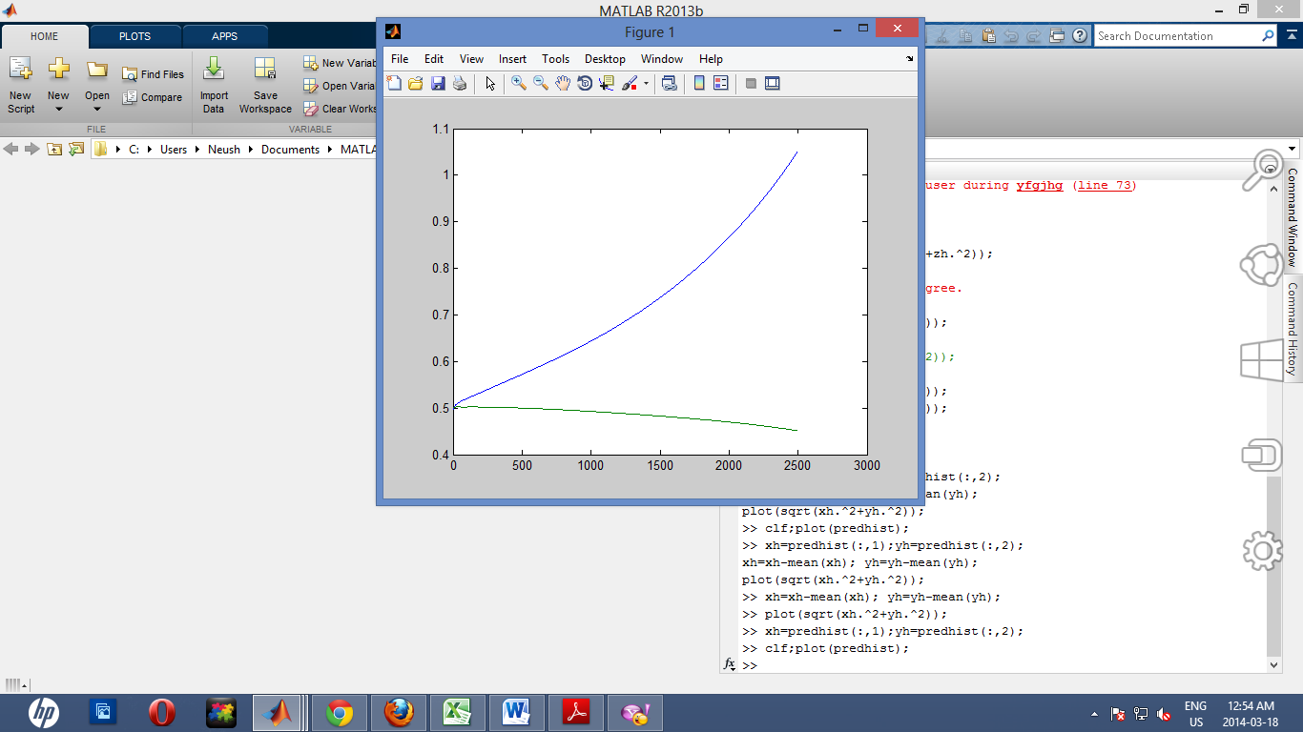

X-values

Y-values

X-values

Y-values

**Figure 2.**The 2-dimensional plots which have the values for n=50, a=1, b=0.2, *dt* =0.02.The left plot is the graph of *predhist* function when c=0.15.

**Figure 3.**The 2-dimensional plots which have the values for n=50, a=1, b=0.2, *dt* =0.02.The left plot is the graph of *predhist* function when c=6.

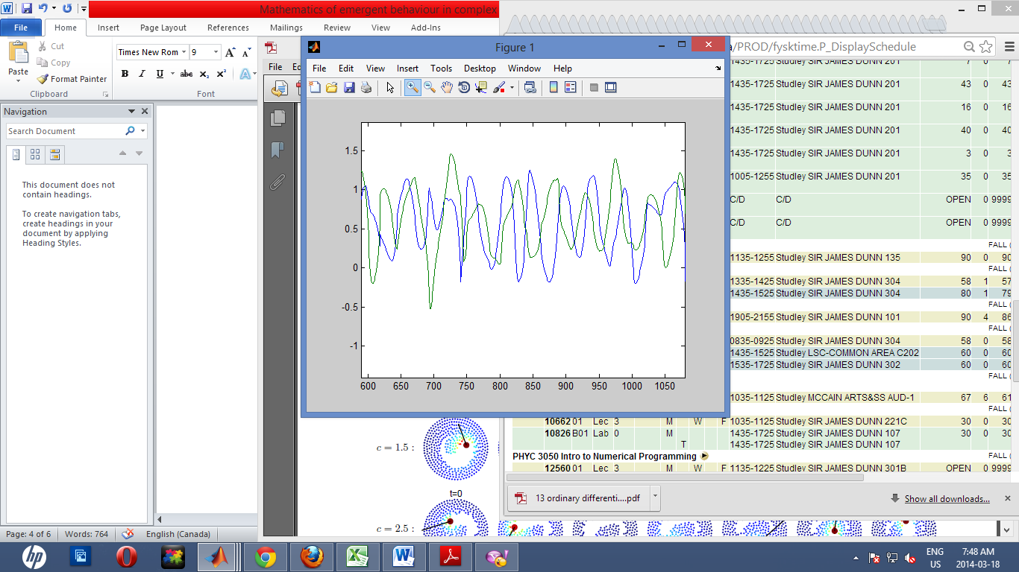

X-values

Y-values

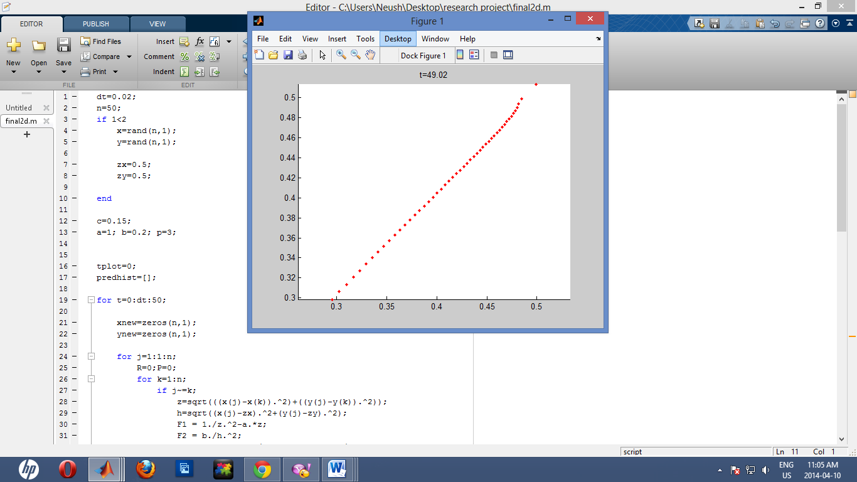

**Figure 4.**The 2-dimensional plots which have the values for n=50, a=1, b=0.2, *dt* =0.02.Starting from the left, the plot shows the trajectory of the predator with c=0.15

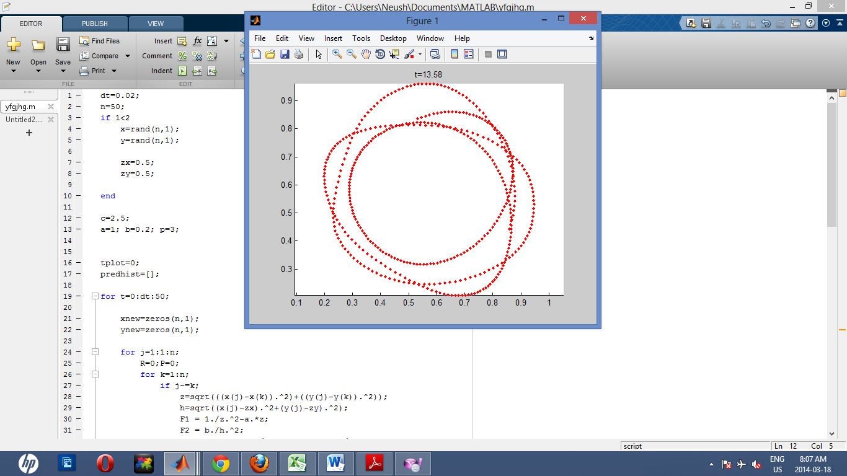

**Figure 5.**The 2-dimensional plots which have the values for n=50, a=1, b=0.2, *dt* =0.02.Starting from the left, the plot shows the trajectory of the predator with c=6



**Figure 6.**The 3-dimensional model of single predaor which have the values of n=50, a=1, b=0.2and p=3, *dt*=0.1.

X-values

Y-values

Z-Values

C=17

C=10

C=20.8

C=20

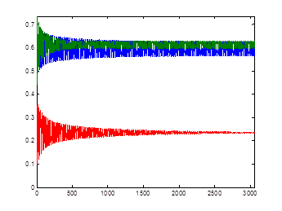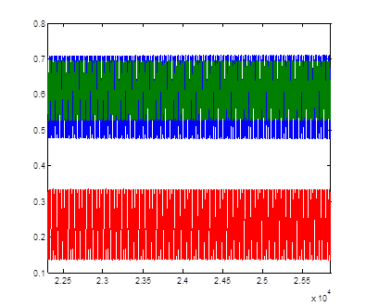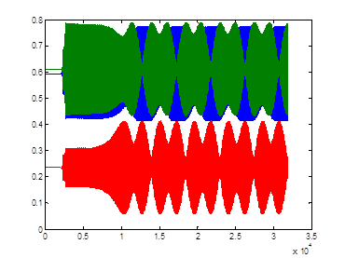

**Figure 7.**The 3-dimensional plots which have the same values for for n=50, a=1, b=0.2,p=3and *dt* =0.1.The plot is the *predhist* function respect to time with the written *c* values.



C=20.8

C=20

C=17

C=10

**Figure 8**.The 3-dimensional plots which have the same values which are n=50, a=1, b=0.2,p=3and *dt* =0.1.The plot is predator’s trajectory respect to time with the written *c* values.



**Figure 9**.The 3-dimensional plot and the predhist plot of when n=50, a=1, b=0.2,p=3, *dt* =0.1 snd c=0.

**Figure 10.** The 3-dimensional plot (right-side) and the 2-dimensional plot (left-side) which representing the general trajectory of the preys.

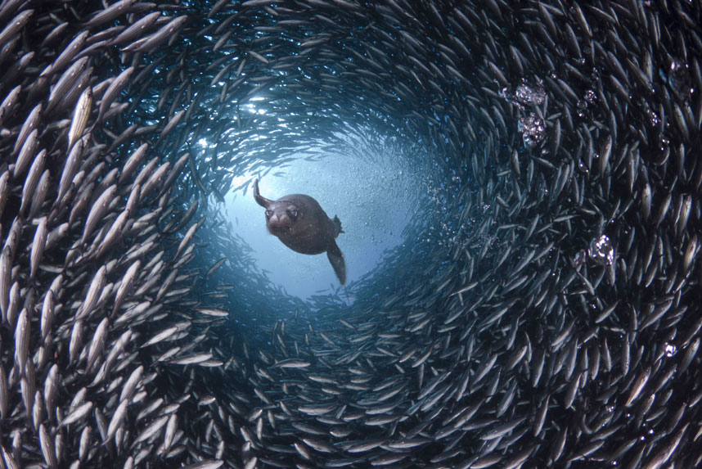

**Figure 11.**The sea lion and the fish swarm picture tunnel token by David Fleetham

X-values

Y-values

Z-Values

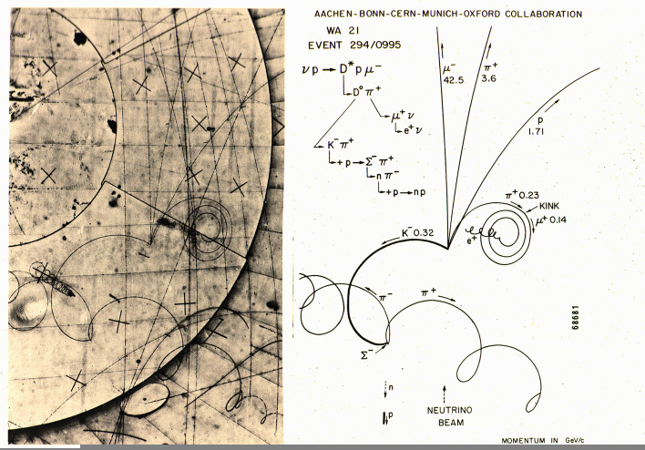

**Figure12.** Production and decay of a D* during a wide band exposure in experiment WA21, in the BEBC liquid hydrogen bubble chamber. Credit: CERN PhotoLab